Part 1: Written Exercise - Understanding Programming
1. What is computer programming, and why is it important?
Computer programming is the process of writing instructions that tell a computer how to perform tasks and solve problems. It is important because software, websites, mobile applications, artificial intelligence, and many modern technologies depend on computer programs.
2. What is Python, and why is it popular with beginners?
Python is a high-level programming language used to create applications, automate tasks, analyze data, and develop artificial intelligence. It is popular with beginners because its syntax is simple and easy to read, making it easier to learn programming concepts.
3. What do you need to start writing and running Python programs?
You need to install Python on your computer, which includes the Python interpreter that runs your programs. You also need a code editor or Integrated Development Environment (IDE), such as Visual Studio Code, PyCharm, or IDLE, to write and execute your Python code.

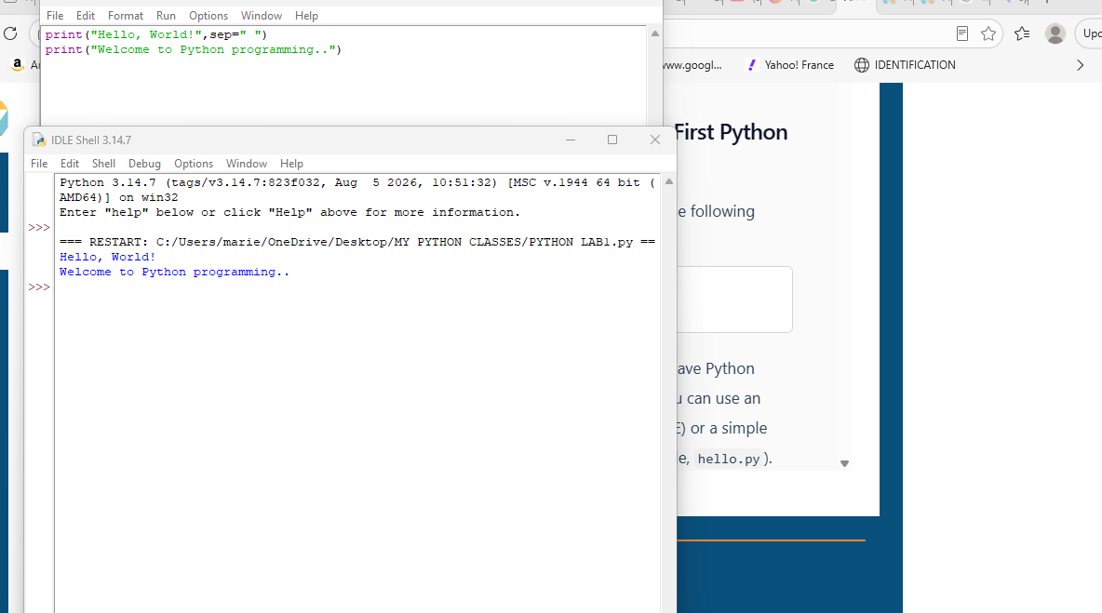

Part 2: Coding Exercise - Your First Python Program
